**Process Selection**

Initially when we started thinking about process framework, we were clear with that fact that we need a process framework with defined roles, work breakdown which can guide us throughout our project duration but at the same time light weighted since our practicum duration is short(only 2 semesters). A process which is heavy and more documentation demanding will hamper our progress in other process areas as well as the technical aspects. So we started by listing few of the process frameworks which we came up with as a result of brainstorming. Then we used the papers “Choose your Weapon Wisely” and “Choose your Cave weapon wisely” from our Managing Software Development class and answered the questions given in the paper. Finally based on the scores, we decided the process framework.

The following are the process frameworks we considered.

|  |  |  |  |  |  |  |
| --- | --- | --- | --- | --- | --- | --- |
|  | **Scrum** | **XP** | **TSP** | **OUP** | **RUP** | **ACDM** |
| **Team Size** | 3 | 3 | 3 | 3 | 1 | 3 |
| **Total Developers** | 2 | 2 | 2 | 2 | 2 | 2 |
| **Product Size and Complexity** | 3 | 3 | 1 | 3 | 1 | 3 |
| **Level of Hacker sentiment** | 1 | 1 | 3 | 2 | 3 | 3 |
| **Management Style** | 2 | 2 | 2 | 2 | 3 | 2 |
| **Process Maturity** | 1 | 1 | 1 | 1 | 3 | 3 |
| **Requirements Stability** | 3 | 3 | 2 | 3 | 2 | 2 |
| **Requirements Traceability** | 1 | 1 | 2 | 2 | 2 | 2 |
| **Type of product** | 2 | 2 | 2 | 1 | 2 | 2 |
| **Work Demonstration** | 3 | 3 | 2 | 3 | 2 | 1 |
| **Learning curve for Project Management Techniques** | 3 | 3 | 1 | 3 | 1 | 2 |
| **Total** | **24** | **24** | **21** | **25** | **22** | **25** |

Though XP,Scrum,OUP and ACDM were among the top 4 in the total score, **we decided to follow Open UP** because of the following reasons:

i) The level of Hacker sentiment in all the team members is zero because the essence of MSIT program is to learn from experience. So we want to follow all the practise areas properly without hacking code and getting the work done. Hence XP and Scrum are ruled out and Open UP seems to match our fit since it has well defined roles, tasks and work breakdown.

ii) Requirements traceability is very important as its a critical project which deals with critical information like bank transactions, stock market details, etc. So clearly OUP stands over XP and Scrum in such a scenario.

iii) It is a light-weight process framework but has well defined tasks, roles and work breakdown. Hence the team will get an experience in all the practise areas though its light-weighted. Also OUP doesn’t require excessive documentation which helps the team in managing the tasks at hands easily as the number of team members is very less.

From the above table we identified that there are 4 process which could suit our needs. These processes are XP, Scrum, Open UP and ACDM. We zeroed down on Open UP for our project process. Here is the rationale behind choosing OPen UP or we can also say why not other:

**XP and SCRUM:** Both XP and Scrum needs the availability of a customer. Considering our academic schedule and our timeline for studies. We had very limited time left that we can dedicate to the project. Our client was not available locally; his office was in California, in PST timezone. So from the available time finding a common time would be very difficult. Plus the process needs daily interaction with the customer.

The main focus of XP is to start coding as soon as possible. Following XP would also affect the 7 practice areas we needed to address for the course.

Ref. : <http://www.extremeprogramming.org/>

**Scrum** Daily scrum meeting were not possible. In scrum the main focus is on product increment whereas that was not the only focus of the team; Team wanted to explore more and utilize the time completely to understand various roles and responsibilities.

**ACDM:** Our project is likely to be a scratch up project.As per the discussion with the client we were free to use any technology and design to acheive our goals. There is a good scope for changing requirement here. In ACDM the volatility of requirements affect the architecture deeply and we do not have time to take that risk. Other than that the process is very heavy on documentation side. Our team is looking for something light weighted. Given the time boundaries, we were of the opinion that we should not go with a process with heavy documentation that will only give us less time to explore existing technology and similar project

**Open UP:** We were left with only one option to explore and that did the trick. Before looking into the processes, team identified certain roles which team must have in order to address 7 quality areas and take the blame for. Open up is agile (our customer wanted), agile is light weighted (team wanted). The core principles aligns with team’s ideology.

* Collaborate to align interests and share understanding. This principle

promotes practices that foster a healthy team environment, enable collaboration

and develop a shared understanding of the project.

* Balance competing priorities to maximize stakeholder value. This principle

promotes practices that allow project participants and stakeholders to develop a

solution that maximizes stakeholder benefits, and is compliant with constraints

placed on the project.

* Focus on the architecture early to minimize risks and organize development.

This principle promotes practices that allow the team to focus on architecture to

minimize risks and organize development.

* Evolve to continuously obtain feedback and improve. This principle promotes

practices that allow the team to get early and continuous feedback from

stakeholders, and demonstrate incremental value to them.

Iteration template of Openup and its Phases objective gave us exactly what we wanted:

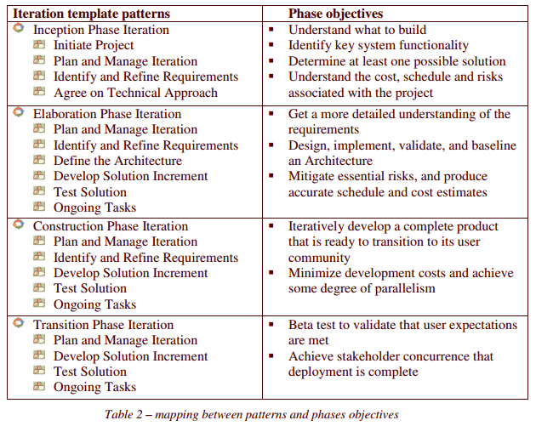

Hence the decision was made.